Week 3 Exercise
Objective 1: Conceptual Foundations
In the late 2000s (around 2007–2008), Facebook faced a major analytics challenge: engineers needed to query massive datasets stored in Hadoop, but most analysts only knew SQL. At the time, working directly with Hadoop required writing Java-based MapReduce jobs, which created a steep barrier for non-engineers. Hive was created to solve this problem by providing a SQL-like interface that allows users to query large-scale data without writing Java code. Users can interact with Hive through a command-line interface or connect it to BI tools such as Tableau or Power BI, making large-scale data analysis accessible to analysts and data scientists who are already familiar with SQL.
Hive operates through a layered architecture. When a user submits a SQL query, the Hive driver first parses it and converts it into an abstract syntax tree. The optimizer then analyzes the query and determines an efficient execution plan. That plan is passed to the execution engine, which translates the query into distributed jobs. Historically, these jobs ran as MapReduce tasks managed by YARN, but modern Hive commonly uses engines like Tez or Spark for better performance. The actual data is stored in Hadoop Distributed File System (HDFS), and the execution engine processes that data in parallel across the cluster.
Hive differs from a traditional DBMS because it is not a database itself—it is a SQL translation and execution layer that sits on top of distributed storage. Its role is similar to modern “serverless” query services such as AWS Athena, Azure Synapse (serverless SQL), and Google BigQuery, which also allow SQL queries over large datasets without managing infrastructure. Hive relies on a metastore to store metadata such as table schemas, column types, and data locations, while the raw data lives in HDFS. When a managed Hive table is dropped, both the metadata and the underlying HDFS data are deleted; external tables are an exception, as dropping them removes only the metadata and leaves the data intact. Hive also supports both ACID and non-ACID tables: ACID tables provide transactional guarantees using formats like ORC and additional metadata, while non-ACID tables are simpler and optimized for read-heavy or external data use cases.
Objective 2 – Resize Google VM
To edit the VM, we’ll first stop it using Google Console. Changing the resources will allow the VM to process higher volumes of data. We’ll be sure to adjust the VM only after powered down. While these big data tools will process data with more efficacy, we will still need to add more CPUs/RAM.
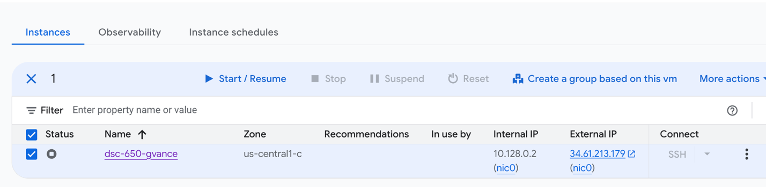
Objective 3: Hive Managed Tables
We’ll run the query (a basic select *) to confirm that the table was created and we can access the data inside hive.
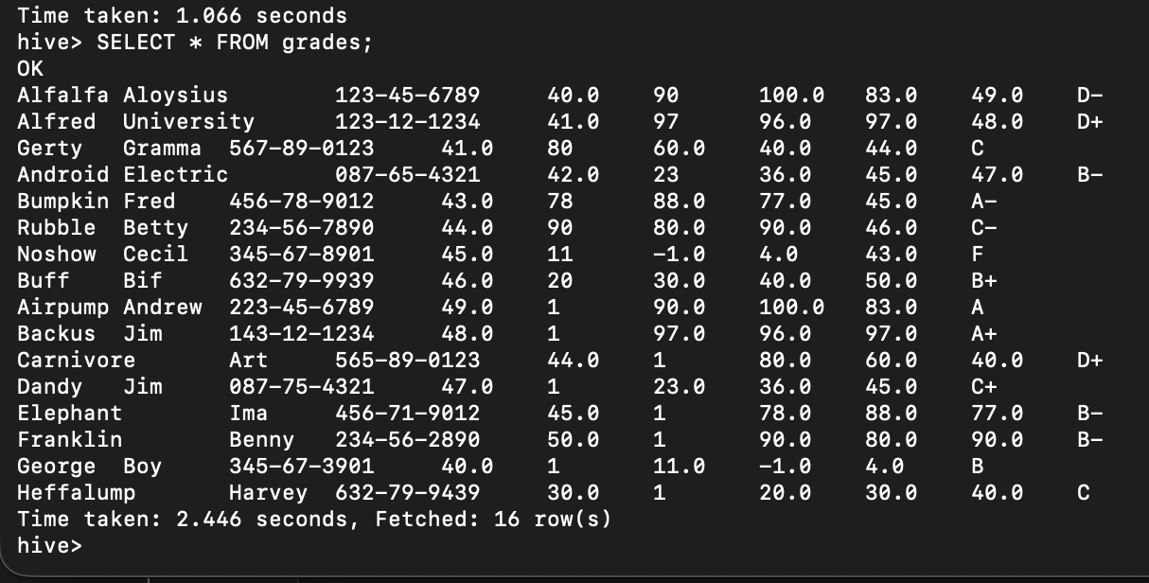
First query is a basic select *, but orders by description. Because we pass in the 8th column, we sort without requiring the name.

SELECT * FROM grades ORDER BY 8 DESC; This sorts by the 8th column

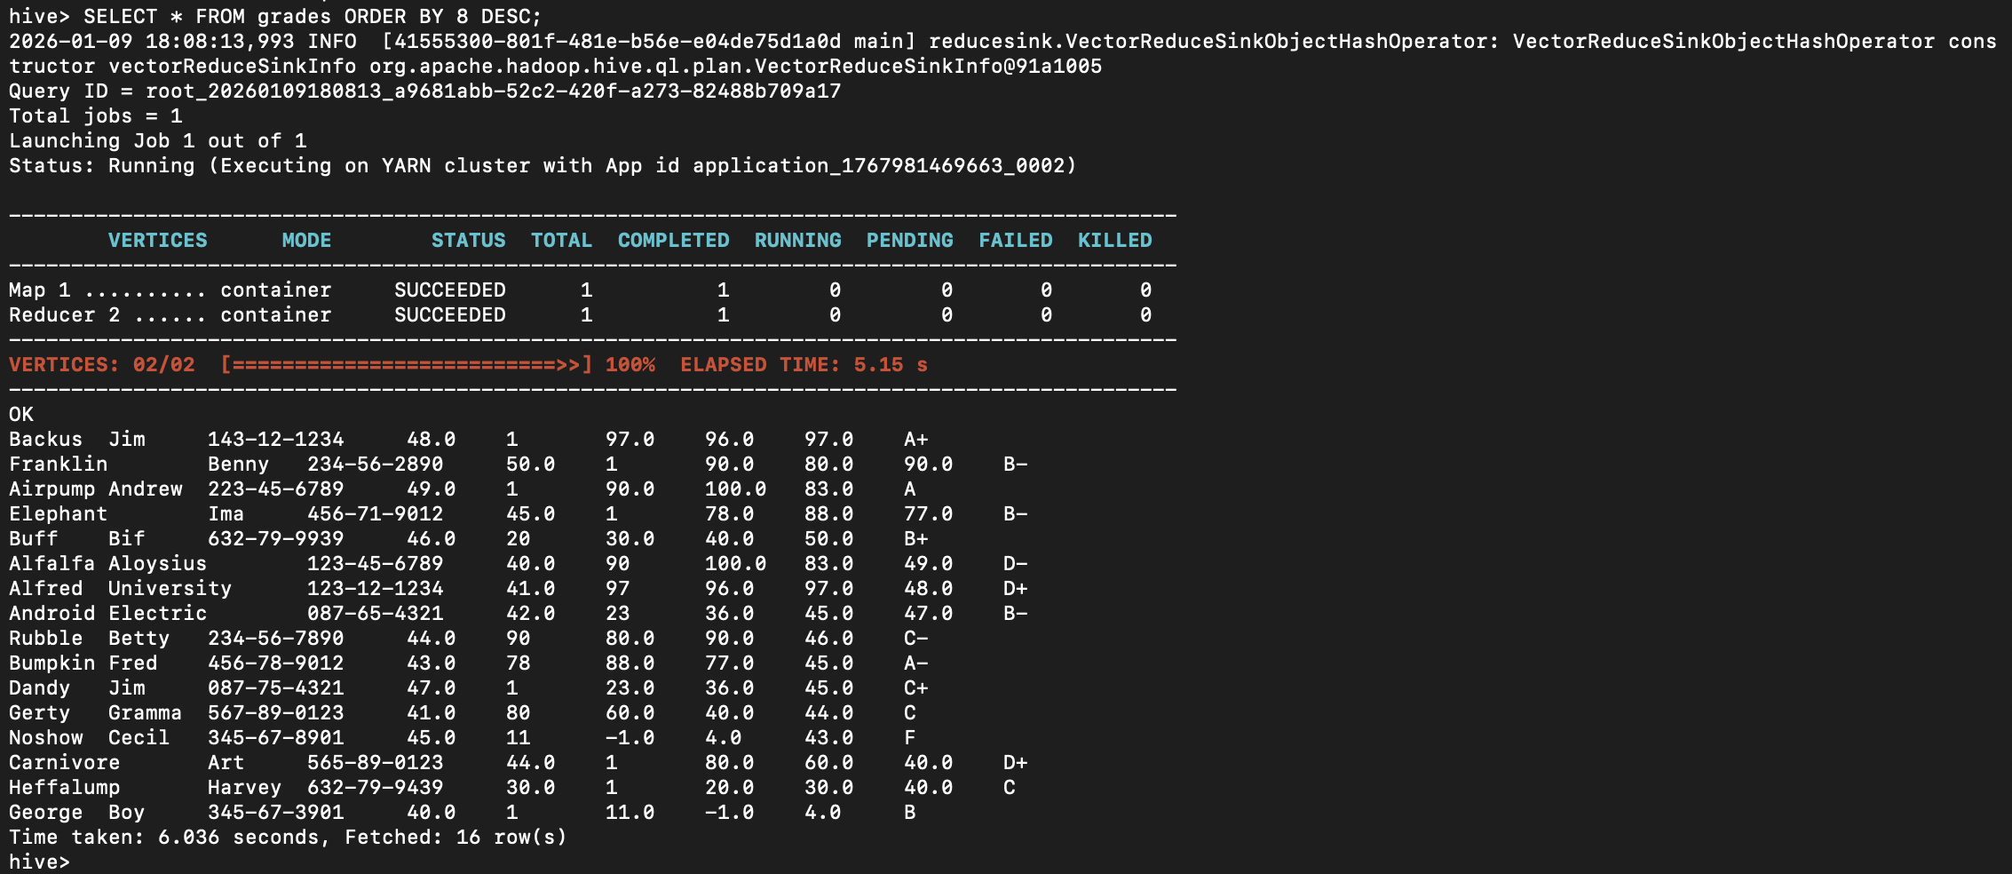
Next query assigns an alias for the average of test scores.
SELECT AVG(test1) AS avg_final_score FROM grades;
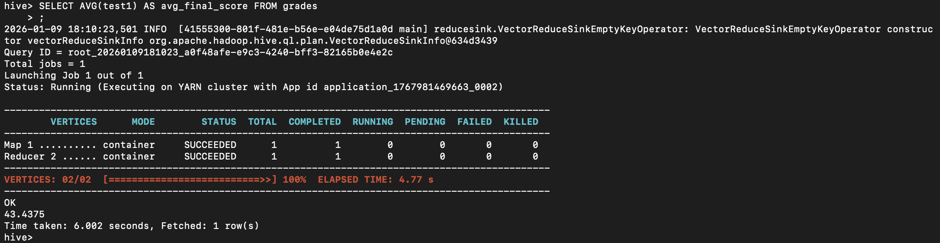
The third and final query counts the students per grade so we can group/bin the dataset.
SELECT final, COUNT(*) FROM grades GROUP BY final;

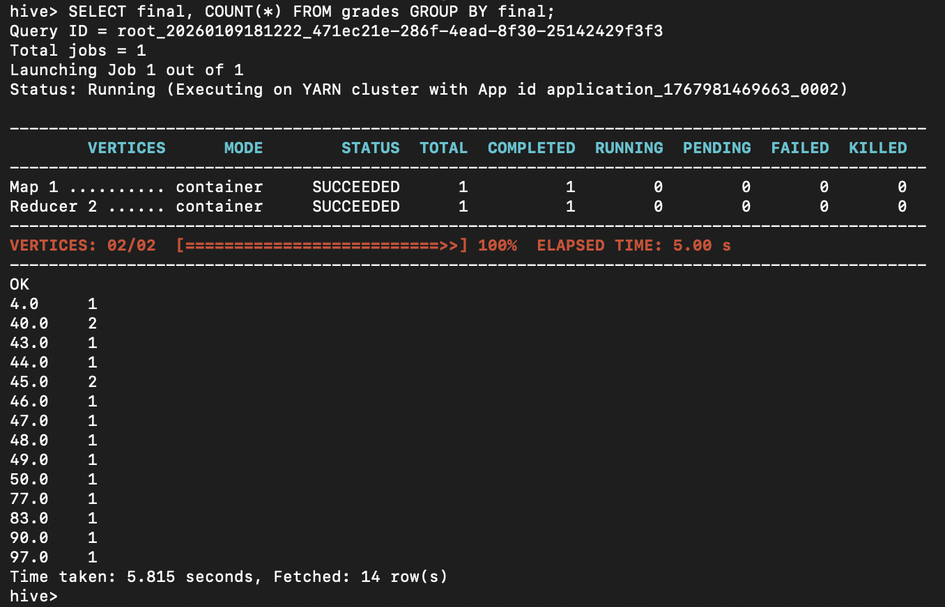

Objective 4: Hive with a new Dataset
The dataset is from Kaggle. It was loaded into github and then downloaded using the wget command. Once inside the container, the csv was moved into the HDFS, and it was accessible to Hive. However, we first needed a table to perform queries against.

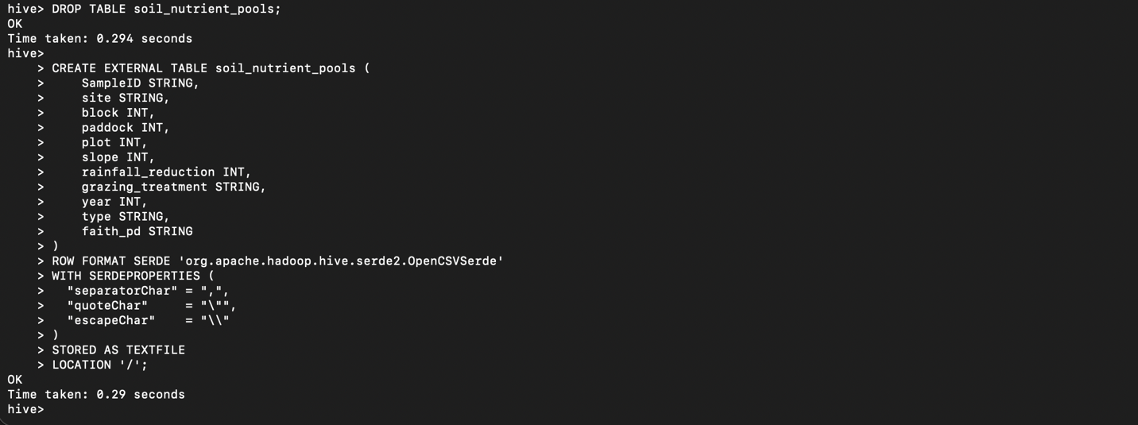
First we do a basic query * count to see if Hive can read the rows. This is important because the first time I made a table, I had to drop it because while the table creation command succeeded, the location was wrong, which led to returning 0 for the counts. Note that this command took 37 seconds to load because we had a large number of rows.
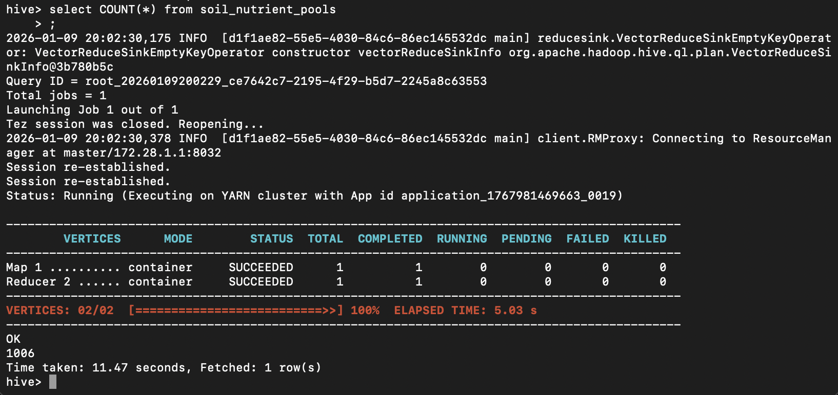
The next query selected certain columns, such as site, year, and type. Limit results to 5.
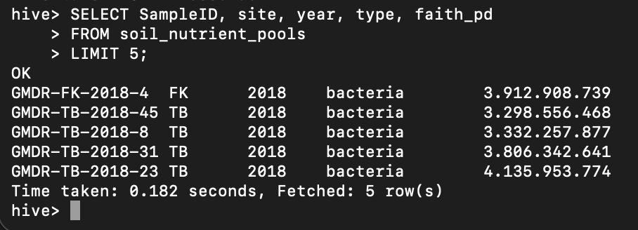
The 3rd query grouped by site, which turned out to only be 3 groups total.
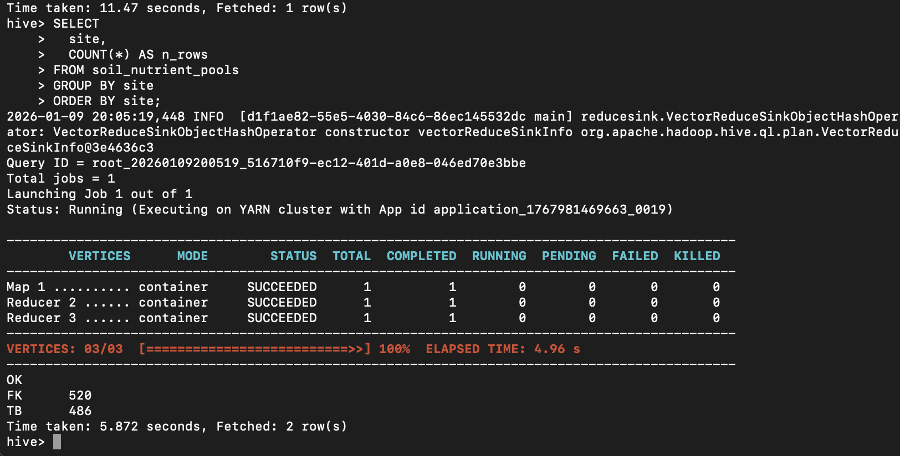

Now we will run explain with each SQL to extract the stages of each query.

• How many stages are involved.
o 2 stages – a fetch stage and a distributed execution stage using Map → Reduce.
• Whether the query sorts or aggregates data.
o It aggregates data using a global COUNT(*).
• What the shuffle process is doing.
o The partition-only shuffle sends partial counts from each mapper, which processes a chunk of the table, to the reducer where they are combined.
• How Hive is translating your SQL into distributed execution.
o Hive splits the table into chunks, processes them in parallel on multiple machines, and reduces the partial results into a single final count.

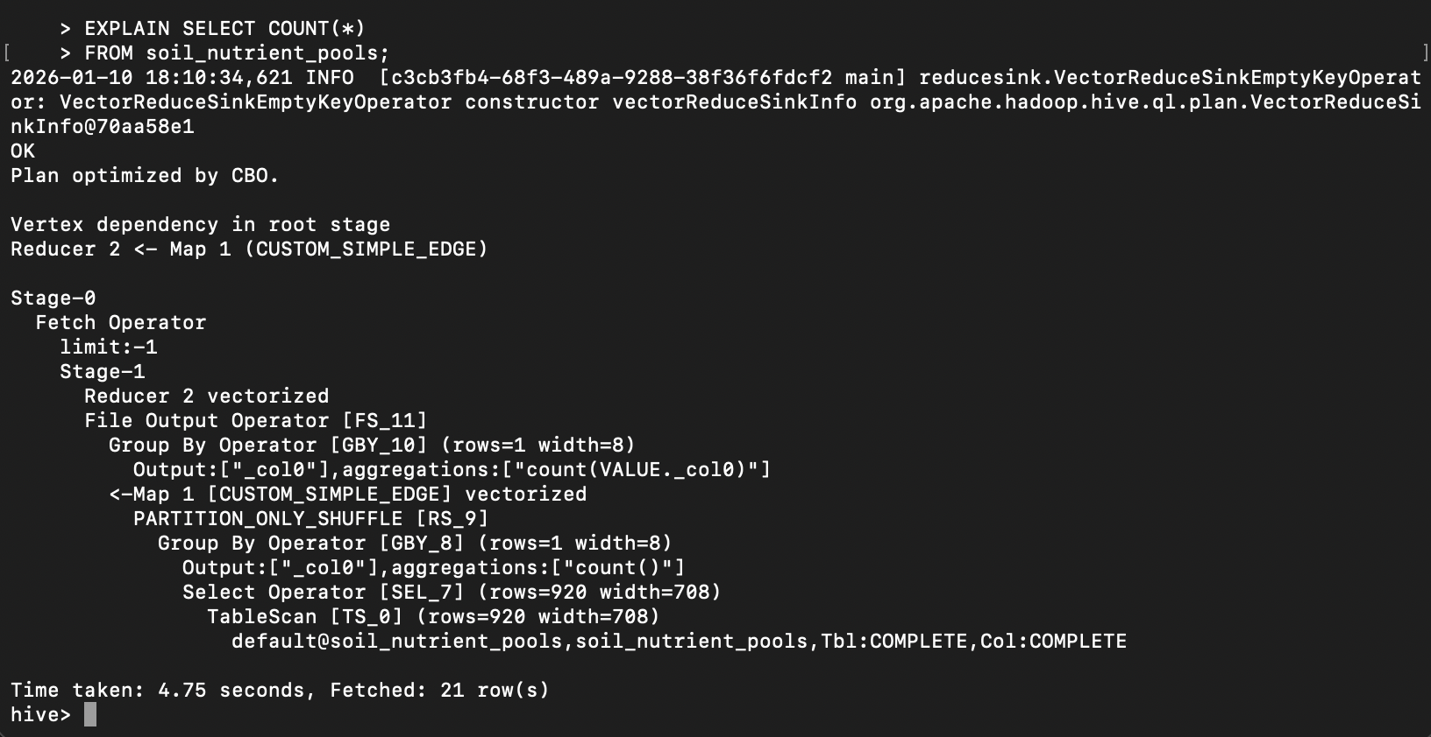
• How many stages are involved.
o 1 stage – a fetch stage only. Hive scans the table and returns rows directly. There is no map-reduce stage.
• Whether the query sorts or aggregates data.
o It does not sort or aggregate. There is no ORDER BY or aggregation function; it simply reads rows.
• What the shuffle process is doing.
o No shuffle occurs. Since there is no aggregation or grouping, Hive does not move data between machines.
• How Hive is translating your SQL into distributed execution.
o Hive scans the table, selects the requested columns, stops after retrieving 5 rows due to the LIMIT, and returns the result without performing distributed aggregation.

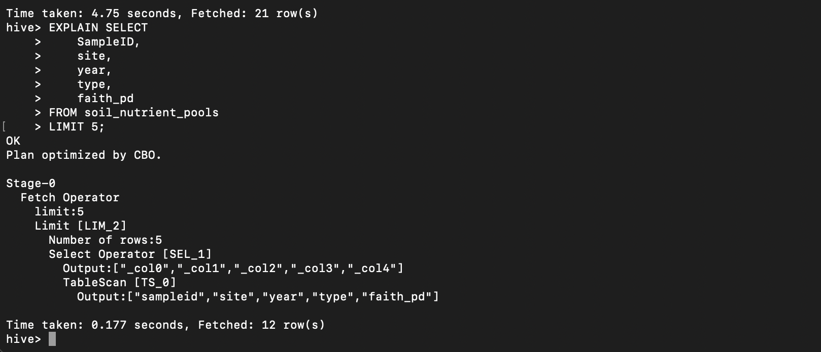

• How many stages are involved.
o 1 stage – a fetch stage only. Hive scans the table and returns rows directly.
• Whether the query sorts or aggregates data.
o It neither sorts nor aggregates data. The query simply selects columns and limits the output.
• What the shuffle process is doing.
o No shuffle occurs. Since there is no aggregation or grouping, Hive does not move data between machines.
• How Hive is translating your SQL into distributed execution.
o Hive reads the table, selects the specified columns, stops after retrieving 5 rows due to the LIMIT, and returns the results without any distributed reduction.

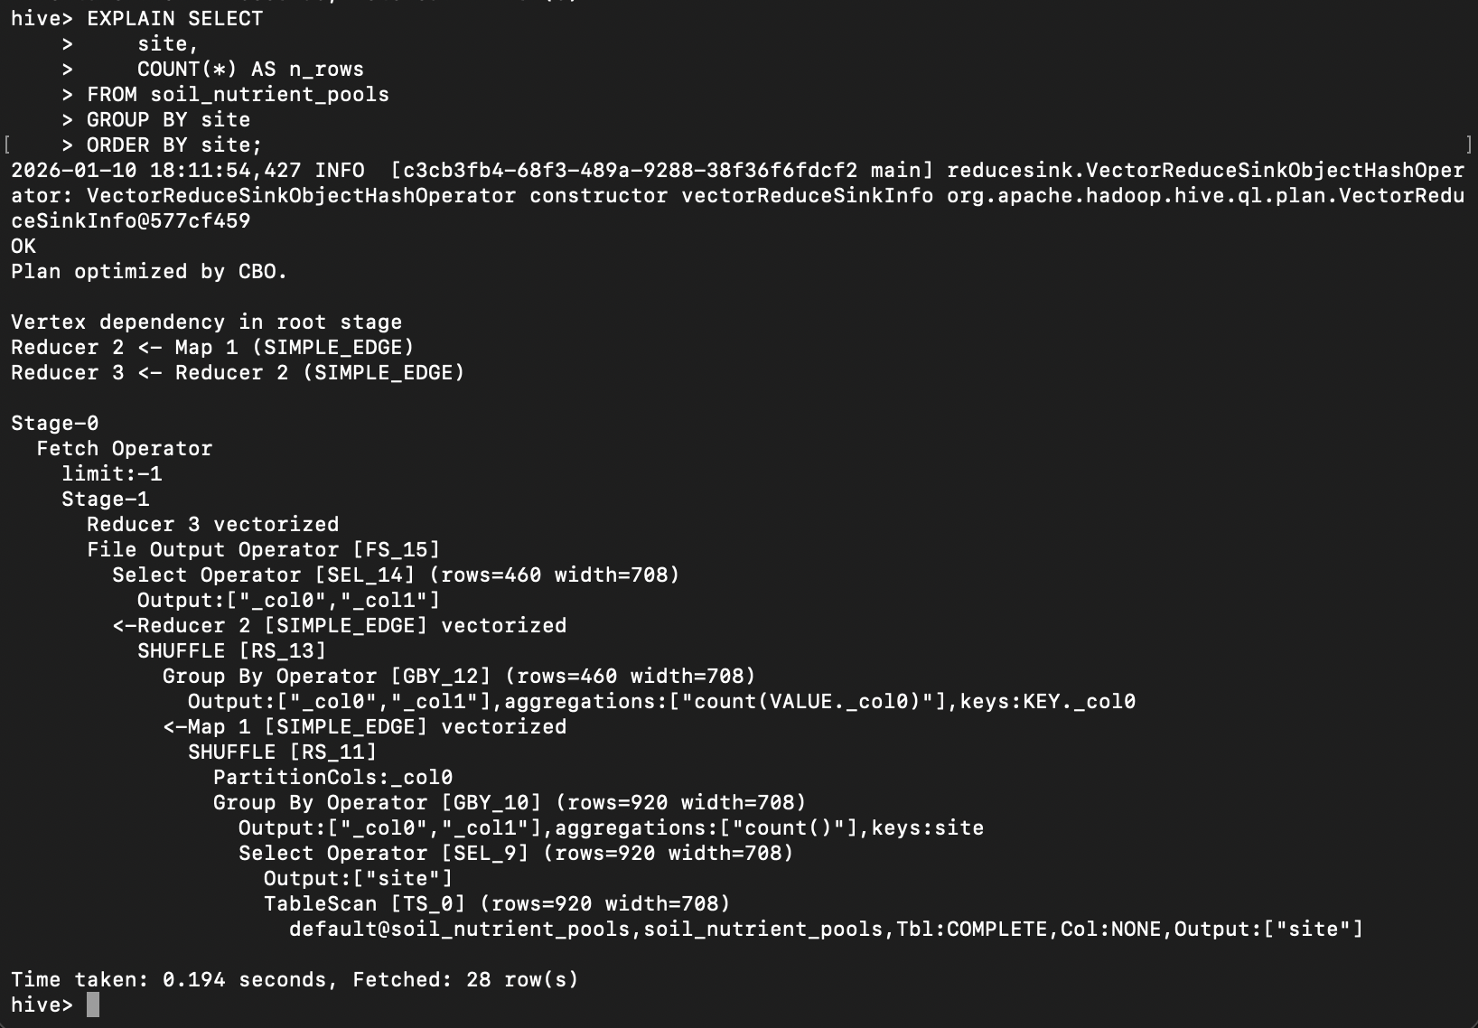

Objective 5: Hive External Tables
In the last step we’re going to add an external table to demonstrate the schema-on-read-capability. First we’ll add the table along with a basic query to verify the results are present.
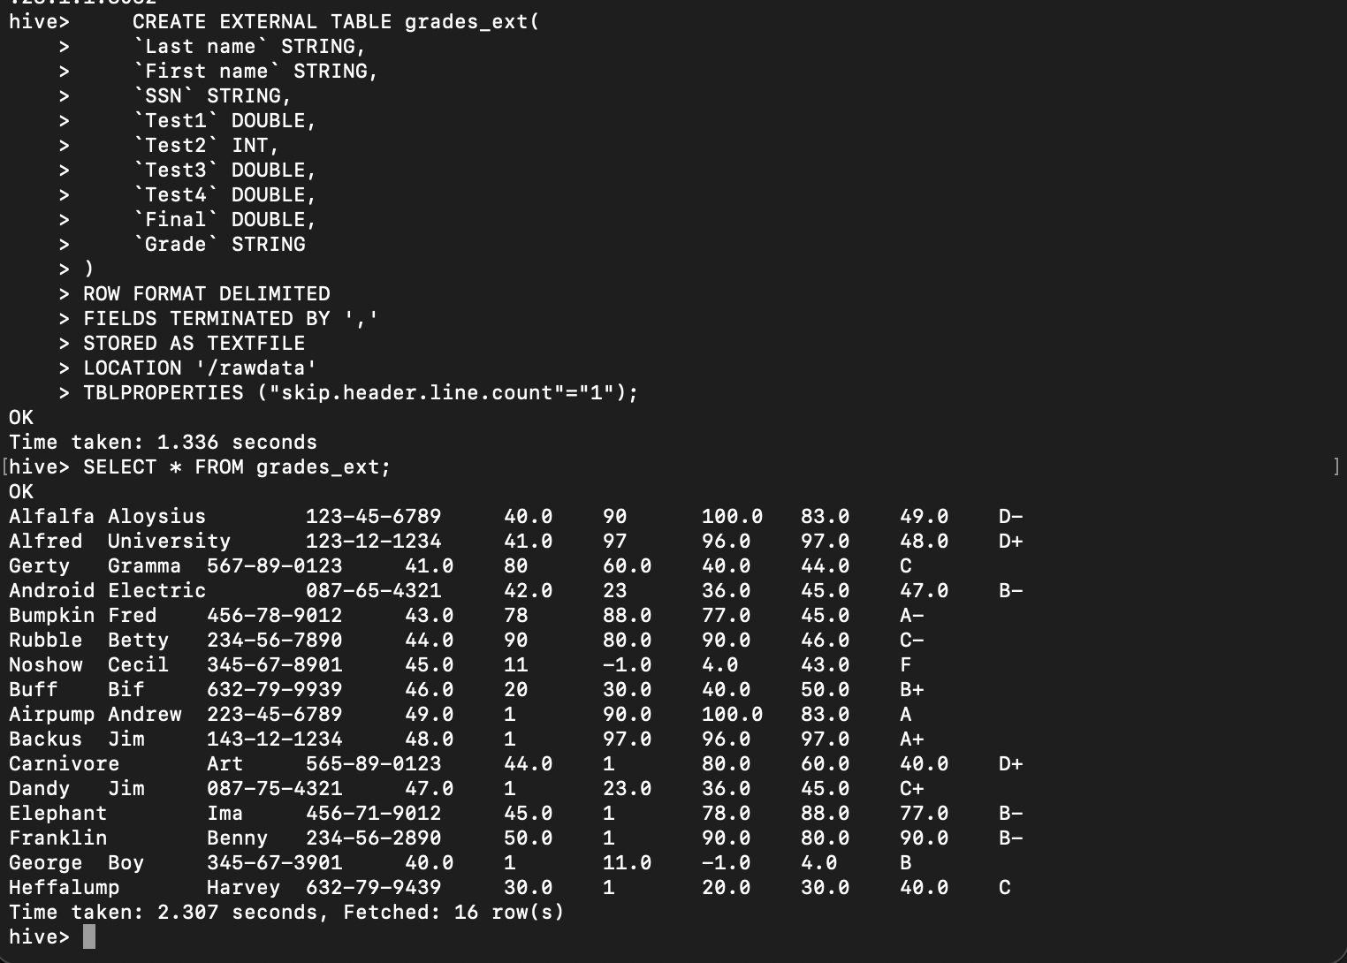
Next, we’ll drop the table inside Hive. This is completely okay because we will not be losing the original data!
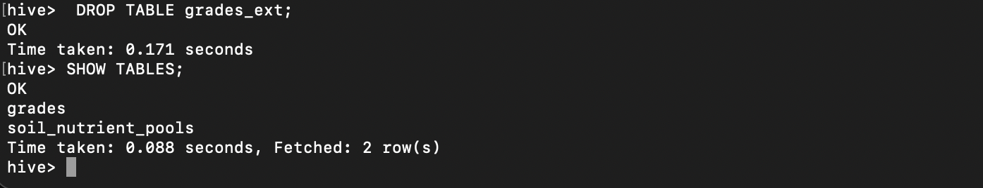
Dropping the external table removes only Hive’s metadata. The underlying CSV file is not deleted, so it remains accessible on the VM’s filesystem.
